Ohio PTA
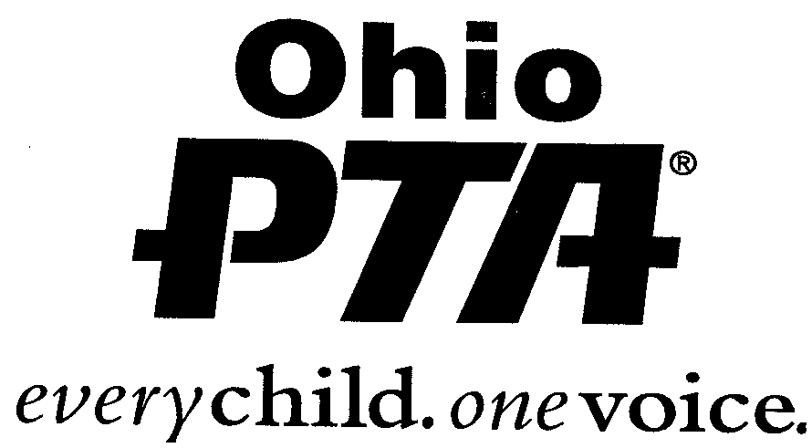
SCHOLARSHIP CONTRIBUTION
FORM

2023-24

Please return this form along with your Unit/Council scholarship check to the Ohio PTA by March 1st. If your Unit participates in a Council Scholarship program – please send your check directly to the Council treasurer or designated person.

Name of PTA Unit or Council: ________________________________________________

County _____________________________________________PTA District #__________

Scholarship Chairperson: ____________________________________________________

Email address: _____________________________________________________________

Home Address_________________________________ City: __________________

Zip Code: ____________ Telephone number: ________________________________

Our Unit/Council is submitting $___________. Our check is made payable to the Ohio PTA.

The monies should be allocated as follows:

___ ($500) Academic Scholarship for students from ___________________________High.

___ ($500) Post- Secondary/Associate Scholarship for students from ______________High.

___ ($500) Special Education Scholarship for Students from_____________________High.

Additional Instructions: ______________________________________________________

________________________________________________________________________.

If instructions require a student to have attended a designated elementary or middle school and no
applicant is available, can the committee choose another applicant from the designated high school? _______yes ________no

We cannot afford a full scholarship but would like to contribute to the General Scholarship Fund.
We are enclosing a check made payable to the Ohio PTA for $______________.

REMEMBER:
- Academic Scholarship - $500
- Post-Secondary/Associate Degree Scholarship - $500
- Special Education Scholarship - $500
- Contributions must accompany this form and be submitted to the
Ohio PTA, 40 Northwoods Blvd. Ste. A, Columbus, OH 43235 postmarked by March 1st.

OPTA Memorial Scholarship Contribution form is now available on-line at
https://ohiopta.memberhub.gives/ohptamemorialscholarshipcontribution

