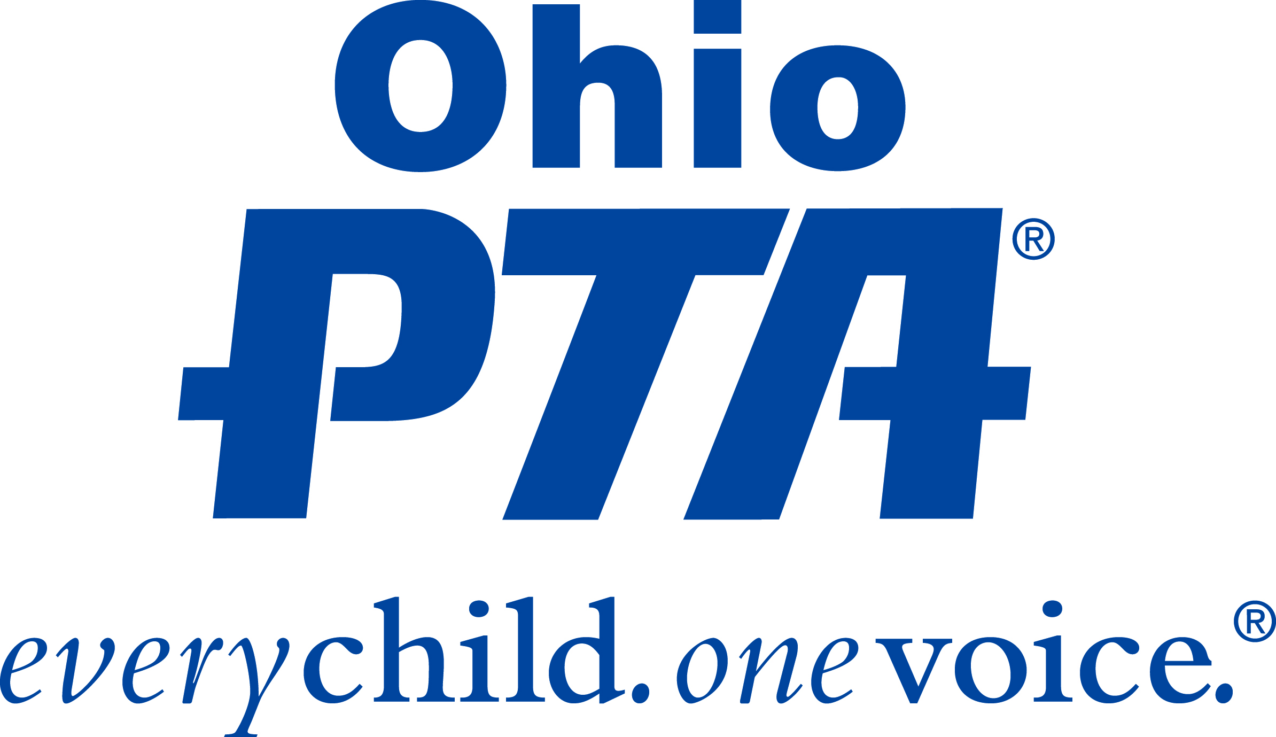

January 2024

Dear Scholarship Counselor,

The Ohio PTA Memorial Scholarship program, in its 77th year, is pleased to once again offer your graduating seniors the opportunity to apply for an Academic, Post-Secondary/Certification, or Special Education Scholarship of $500.00.

The awards are based on the student’s scholarship achievement, school and community involvement, leadership qualifications, and an essay. The applicant must be a senior, who attends an Ohio public high school, in a school district having one or more PTA units with membership in the Ohio PTA.

Recipients are permitted to receive scholarships from other sources. Scholarship checks are mailed directly to the recipient upon verification of their enrollment at an accredited college, university, or technical school.

Scholarship applications can be electronically viewed and completed at the following links:
Digital Application Links:
- Academic Application lhttps://tinyurl.com/OPTA-Scholarship-Academic-2024
- Post-Secondary/Certification | https://tinyurl.com/OPTA-Scholarship-PSCert-2024
- Special Education | https://tinyurl.com/OPTA-Scholarship-SpeEd-2024
We’ve also attached a paper copy of the applications for your convenience. Please feel free to make copies as needed. Additional application information, including a fillable PDF application form, can be found at our website, www.ohiopta.org, under the Programs tab.

To be considered, completed electronic applications must be electronically submitted on or before March 1st, and paper applications must be postmarked on or before March 1st, addressed to the Ohio PTA office. Faxed applications will not be accepted. PLEASE, one application per student.

Both electronic and paper applications must include:
● Ohio PTA Scholarship cover sheet
● Ohio PTA Scholarship application
● school transcript

The scholarship committee asks counselors to encourage students to apply for the Ohio PTA Scholarships. The screening and selection process is the responsibility of the Ohio PTA Memorial Scholarship Committee. We also ask that you please share this information with Principals, Counselors, Vocational Directors, and Special Education Directors.

Thank you for assisting the Ohio PTA in providing opportunities for higher education to your school through the Ohio PTA Memorial Scholarship program. Please contact us at scholarship@ohiopta.org with any questions.

Sincerely,
Angela Revay
Ohio PTA President

